Assessment Parameters

- Solution Completeness (including all requirements addressed) – 20%
- Working solution for each requirement –60 %
- Comments – 10%
- Coding standards – 10 %

- Create a ZXXXXXXEKKO table with the following specifications
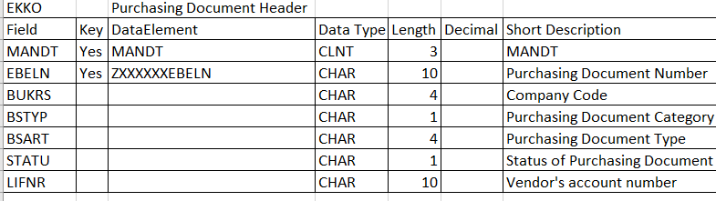The table should contain the following data. Enter records only for 4500000128 and 4500000130.

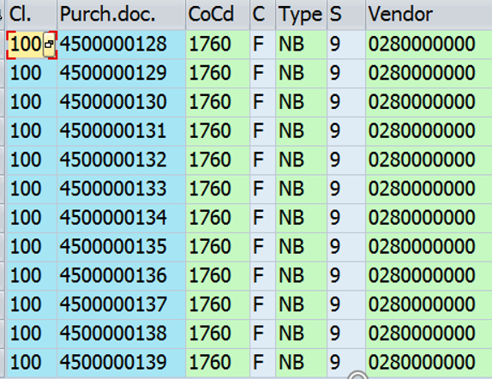

Create Data Elements and Domains as per the requirement.
Note: XXXXXX is your Empcode.
Insert records in the table using TMG. [10].

- Create a ZXXXXXXEKPO table with the following specifications

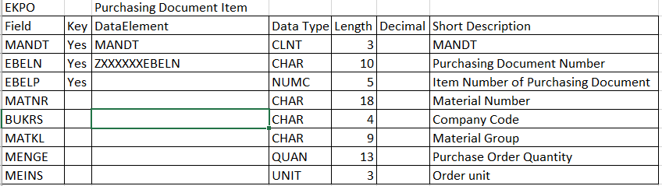
The table should contain the following data.
Enter records only for 4500000128 and 4500000130.

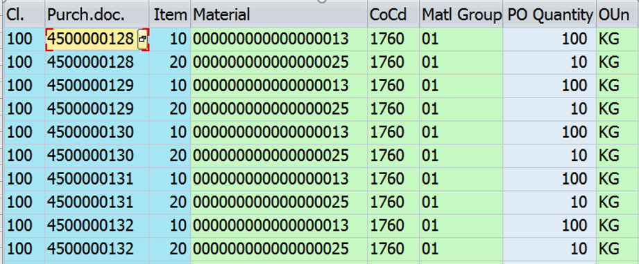

Create Data Elements and Domains as per the requirement.
Note: XXXXXX is your Empcode.
Insert records in the table using TMG. [10].

- Display the Purchasing Document Number the basic list using the ZXXXXXXEKKO table. If a Purchasing Document Number is chosen on this list, then the line items of the Purchase order should be displayed in the next level from ZXXXXXXEKPO Table. [20]

Basic List:
Create a selection screen to accept the range of Purchasing Document Number. Display at least 5 Purchase Orders along with Company Code and Vendor.

Preserve the below details for all the screens to print the header:
Client: 100 User: Sap login user id Date: System Date. Time: System Time.
Basic List
Client | 100 |  | Date | 17.04.2018
User | Trainee01 |  | Time | 11:44:45
Purchase Order Details
Purchase Document Code | Company Code | Vendor
XXX | XXX | XXX
XXX | XXX | XXX

Secondary list
Purchase Order Item Details
Client | 100 |  | Date | 17.04.2018
User | Trainee01 |  | Time | 11:44:45
Purchase Document Code | XXXXX
Item Number | Material Number | Material Group
XXX | XXX | XXX
XXX | XXX | XXX

Note: XXX represents the data.

- Create a Function Module ZXXX_GetPurchase with
- Input parameter Purchasing Document Number (EBELN).
- Output parameter is an internal table of type table ZXXX_EKPO.
- Write Logic in FM to fetch details from table ZXXX_EKPO.

Write a Program that accepts Purchasing Document Number (EBELN) from the user. Program must call the Function Module ZXXX_GetPurchase, pass the Purchasing Document Number (EBELN) to the Function Module.Report should display the Purchase information of all the items from table ZXXX_EKPO for the EBELN accepted from the user.
[ 20 marks]

- Create the Data Base View for the both the tables and write a program to display the data from the view. Select a few fields from both the tables [10 marks].

